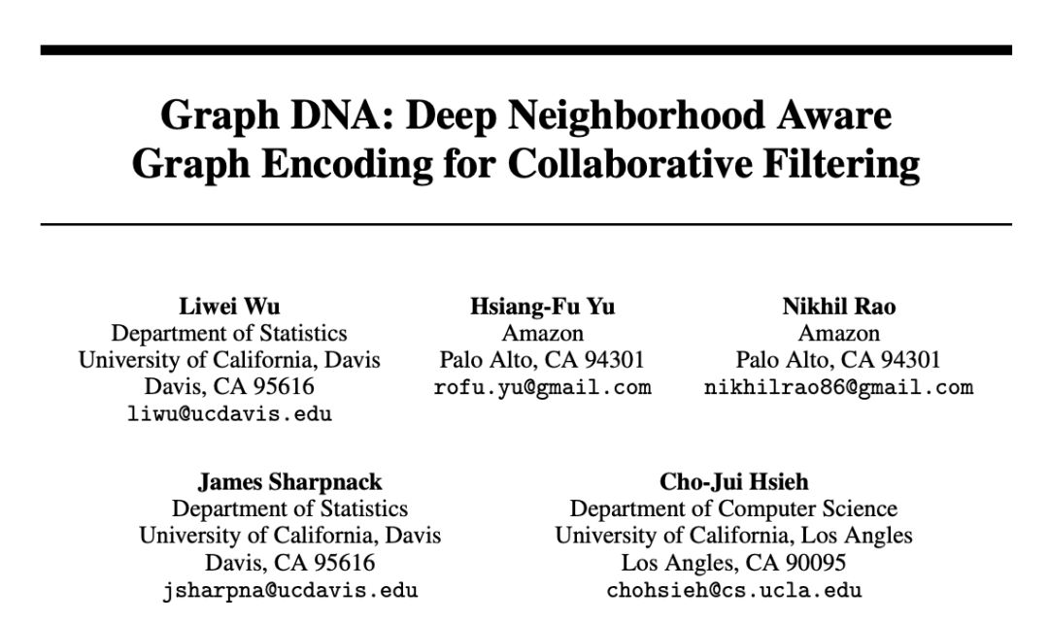

这篇文章考虑的是具有 graph 形式信息的推荐系统。现在的协同过滤算法主要利用直接邻域信息，并不能有效利用超过1～2 阶的更深的邻域信息。挖掘更深图信息的一个主要的问题是，在整合多阶信息时快速增长的时间以及空间复杂度。

In this paper, we consider recommender systems with side information in the form of graphs. Existing collaborative filtering algorithms mainly utilize only immediate neighborhood information and do not efficiently take advantage of deeper neighborhoods beyond 1-2 hops. The main issue with exploiting deeper graph information is the rapidly growing time and space complexity when incorporating information from these neighborhoods.

作者提出了 Graph DNA ，一种先进的 Deep Neighborhood Aware 图编码算法，来探索多阶邻域信息。

In this paper, we propose using Graph DNA, a novel Deep Neighborhood Aware graph encoding algorithm, for exploiting multi-hop neighborhood information.

1. DNA 编码通过使用 Bloom 过滤器计算线性时间内的深度邻域信息，并得到每个节点的编码，每个节点的维度和 graph 中的节点数相同。

DNA encoding computes approximate deep neighborhood information in linear time using Bloom filters, and results in a per-node encoding whose dimension is logarithmic in the number of nodes in the graph.

The Bloom filter [4] is a probabilistic data structure designed to represent a set of elements.

内部用哈希等实现的元素选择器，有三个特点（空间效率，并操作，尺寸小）

Graph DNA Encoding Via Bloom Filters

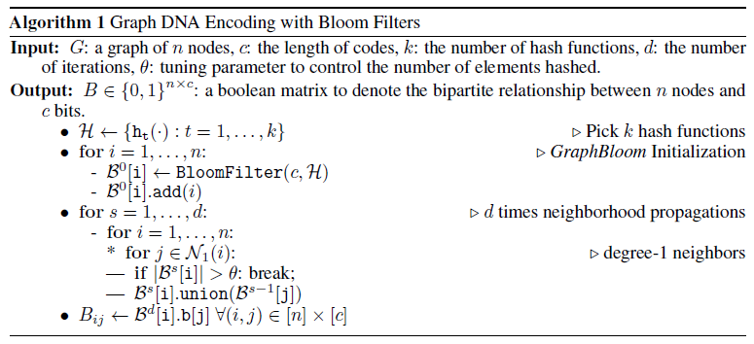

1. 该方法可以同基于特征的以及基于图正则化的协同过滤算法结合使用。

It can be used in conjunction with both feature-based and graph-regularization-based collaborative filtering algorithms.

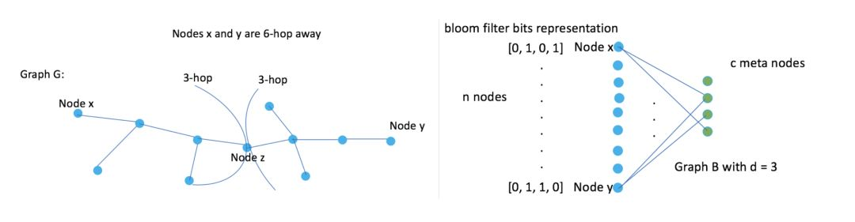

Figure 2: Illustration of our proposed DNA encoding method (DNA-3), with the corresponding bipartite graph representation.

与直接使用高阶图信息相比，Graph DNA 具有存储和时间效率的优势，并且提供额外的正则化。

在推荐系统中，将 Graph DNA 和协同过滤算法结合使用可以以很少的计算和内存开销获得性能的提升。

Graph DNA has the advantages of being memory and time efficient and providing additional regularization when compared to directly using higher order graph information. We provide theoretical performance bounds for graph DNA encoding, and experimentally show that graph DNA can be used with 4 popular collaborative filtering algorithms, leading to a performance boost with little computational and memory overhead.

**论文链接：https://arxiv.org/pdf/1905.12217.pdf**